Personal Information

My name is Debborah Bryce

My student number is s3853719

Email: [debfbryce@gmail.com](mailto:debfbryce@gmail.com)

[S3853719@student.rmit.au](mailto:S3853719@student.rmit.au)

My working background for the last decade has been in aged care, mental health and retail. I’m currently employed at a local IGA as a customer service attendant.

I’m a 4th generation Australian with English and Scottish heritage, I have 4 children, 2 cats and 2 dogs.

My only language is English but am trying to learn Italian and French.

I play netball for emerald netball club, I’m in an open all girl team and play Wing Defence. I also enjoy hiking, bush walking, collecting gems and minerals, going to the Melbourne symphony orchestra, attending TEDX talks, travelling and reading.

I’m also a member of my local Country Women’s Association and volunteer in nursing homes as a lifestyle assistant.

Interest in IT

Information technology has always fascinated me, from gaming to communication, from seeking information instantly to word processing. My family first got a computer in the 90’s but my friends dad had one in the 80’s which was so much fun and mind-blowing as to how it worked. I remember seeing a fax machine in action and thinking “this is amazing!” sending pictures and notes to other friends instantly. Then the internet came along and, in my opinion, communication has never been the same again.

My IT experience is very limited and will probably be evident in this assignment. I have basic knowledge of windows. Word programs, data entry and electronic communication. I’m very excited to learn more.

My reason for choosing RMITO is that it has an exceptional reputation for quality teaching and well-educated students. My other friends have studied with RMIT and recommended learning through them.

I’m expecting to learn about how to use IT programs and applications that will help my future goal of data analysis, data collection and data entry for health organisations, I’m very interested in a career in research and creating tools and products to keep the elderly safe and monitor their health and wellbeing.

Ideal Job

<https://www.seek.com.au/job/41133502?type=standard#searchRequestToken=346d93db-cbf2-434f-aa1d-8de6165b8dab>

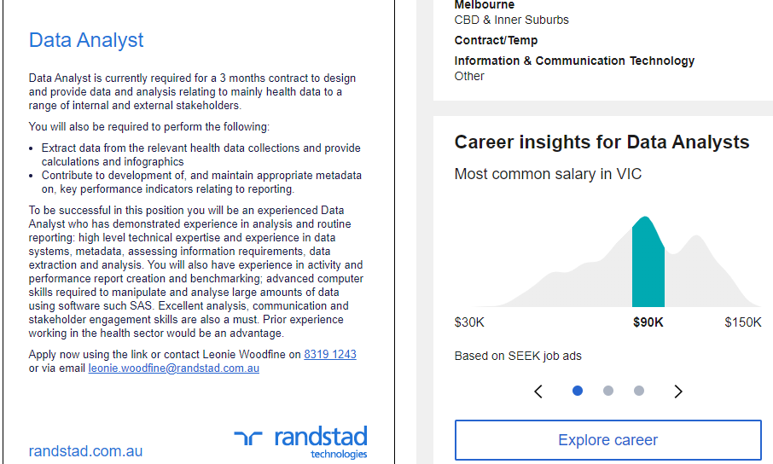

Ranstard Technologies are looking for Data Analyst for a 3-month contract in their Melbourne location. The position is extracting health data from health data collections and contribute to maintaining metadata on KPI’s regarding reporting. This position is appealing for me because I’m very interested in data collection from meta data and other collection sources. This position and job description give me inspiration for future job roles, I’d like to explore.

The skills, experience and qualifications needed for this job position are :

* Experience in Data Analysis and reporting.
* Be an experienced Data Analysts.
* Experience in high level data systems, metadata, data extraction and analysis, assessing information.
* Experience in activity performance reporting and benchmarking.
* Skills to manipulate and analyse high volumes of data and have advanced computer skills to compete these tasks.
* Skills and familiarity with SAS software.
* Prior experience in the health sector.
* Excellent stakeholder engagement skills, a must.

The Plan

In order to be qualified for this position I will need to obtain a qualification in using SAS software and learning more about metadata and analysis. I’ve looked into SAS software and could possibly engage in a short course. I could also look into a traineeship to gain experience and knowledge in data collection, analysis and reporting findings. A bachelor in IT would also be helpful if I was able to complete one.

<https://www.sas.com/offices/asiapacific/sp/training/paths/stat.html>

<https://www.rmit.edu.au/study-with-us/levels-of-study/undergraduate-study/bachelor-degrees/bp162>

Personal Profile

<https://www.truity.com/test/type-finder-personality-test-new>

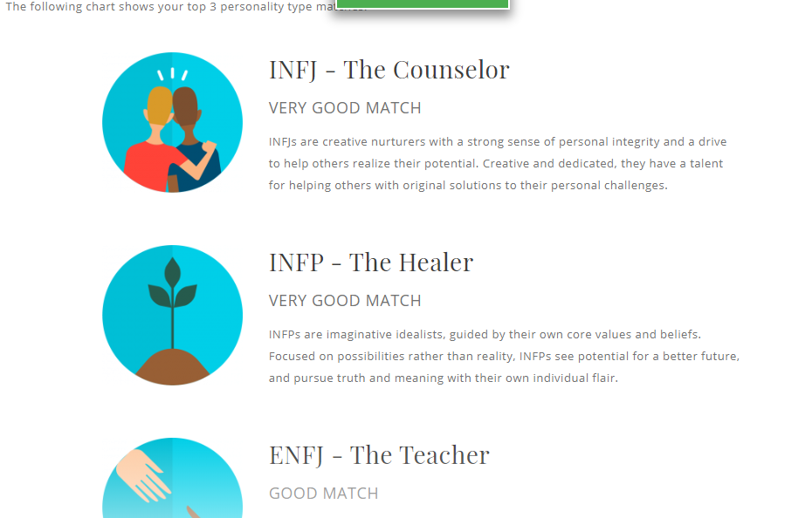

<http://www.educationplanner.org/students/self-assessments/learning-styles-quiz.shtml>

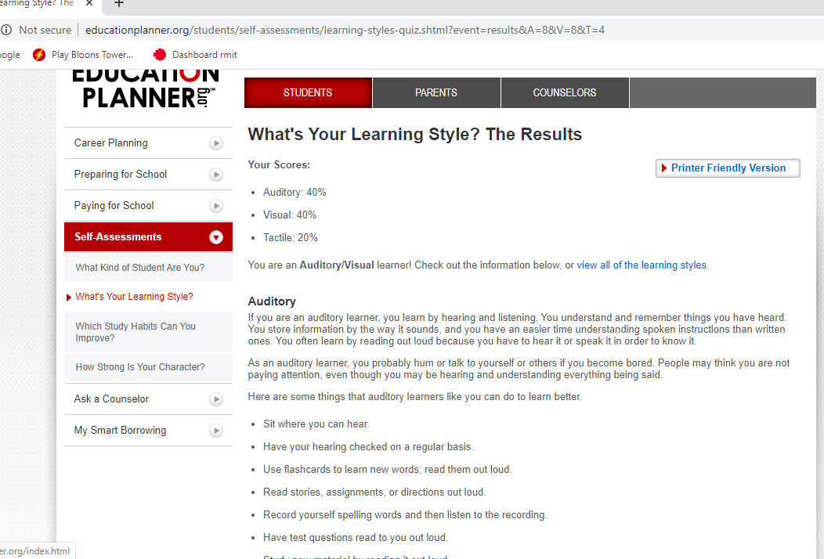

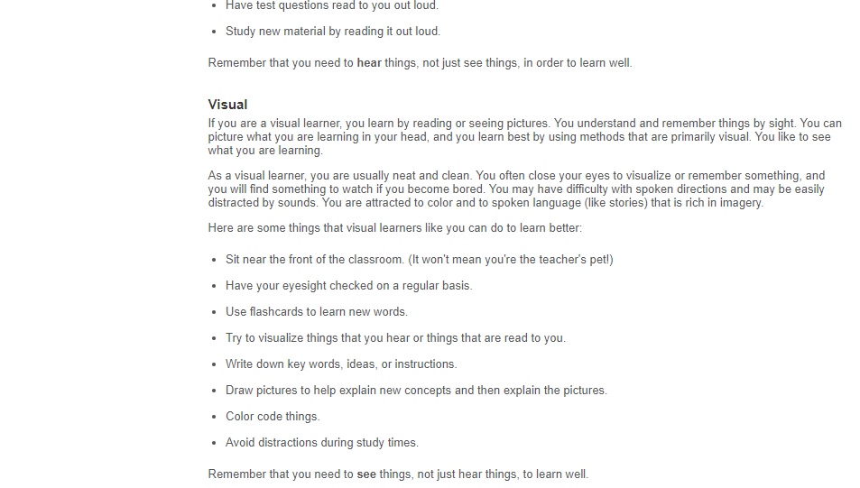

<https://drakep3.com.au/?gclid=Cj0KCQjw09HzBRDrARIsAG60GP-T2eNXGHYMqtjj1P_d0p8yWRFVajq7bQ5rhlNOKJTcbEEmJlKTPQQaAu3QEALw_wcB>

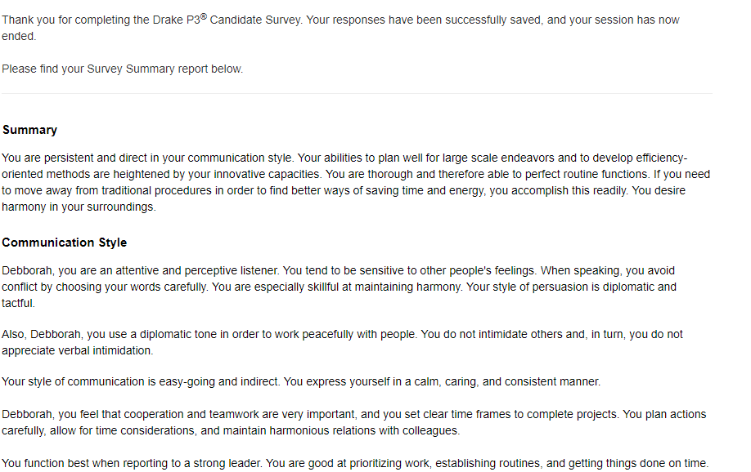

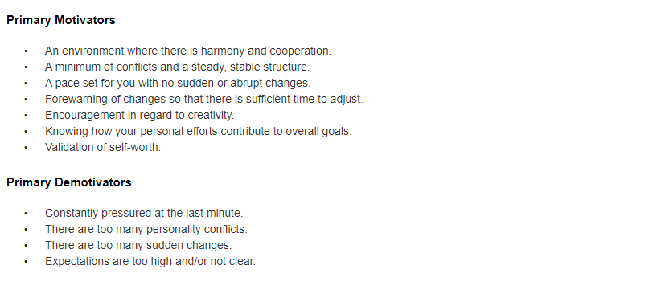

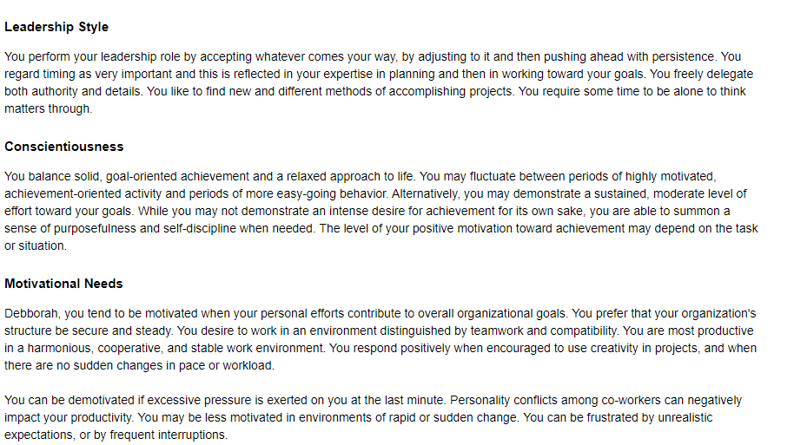

The results from the 3 different tests means I’m able to be more aware of how I operate professionally, socially and how I learn.

These insights into my behaviour, personality and learning style will enable me to be a more effective team member, work with others efficiently and be more productive knowing my role in a group.

When forming a team I could be very good at guiding or facilitating team meetings, establishing teams and assigning roles, I probably wouldn’t be good at making ultimate decisions but could help the team meet a goal and be cohesive and accountable.

Best care practice

Project Idea

**Overview**

To develop software that can collect information about aged care recipients, safety, movements and potential falls risk. Currently we have “fall” matts that set off an alarm to alert carers that a care recipient has made contact with the fall matt, either by stepping on it or lying on it as a result of a fall. The fall matt only alerts carers by an audible alarm that has to be manually shut off with a switch. I f we can combine the fall matt with data collection software we can see the frequency of movement, falls, how long a care recipient was on the fall, time of day, who was alerted and how ie through audible alarm or a message sent to mobile phone.

This will aid allied health professionals, carers and doctors determine best care practice, risk assessment, risk and hazard reduction planning and could also help monitor cognitive decline in care recipients by collecting data on the frequency of falls. Also it could help curb wandering behaviours (behaviours of concern) by establishing patterns in movement and times of day.

**Motivation**

This project will be interesting as having worked in Aged care I’ve seen many incidents of irreversible damage falls can have on the elderly sometimes resulting in fatal outcomes.

According to the World Health Organisation’s ‘Global report on falls prevention in older age’

“*The frequency of falls increases with age and frailty level. Older people who are living in nursing homes fall more often than those who are living in community. Approximately 30-50% of people living in long-term care institutions fall each year, and 40% of them experienced recurrent falls (8).”* (World Health Organisation’s Global Report On Falls Prevention In Older Age, 2007 page 6)

Preventing recurrent falls by collecting data or minimising falls using software and innovative technology would hopefully, result in the aging population living healthier, safer and make caring for them more efficient and easier.

**Description**

By combining the following devices, dual fold floor matt, fall monitor, embedded sensor technology that can connect to existing wi fi infrastructure and cloud data collection and alert systems, the project should be able to monitor, collect data and send alerts to care staff and allied health professionals. The data collected could then also be shared with researchers and innovators to create or enhance the detection devices, monitoring equipment and safety outcomes for the elderly.

**Tools and Technologies**

The dual fold mat features:

Easy to clean fabric

Durable non slip material

Low profile edges to prevent tripping hazard

Embedded sensor technology, that connects to wifi and cloud services

The fall Monitor:

LCD screen to test and reset device

Low battery warning

Easy to use

WIFI connectivity

Plug in or Bluetooth data transfer

Connect to nurse on call system

Cloud data connection is easy to use and can out put information via, mobile phone notification, fax reports, audible alarm system.

Open source cloud providers like Nextcloud or ownCloud

**Skills Required**

Software analysis skills

Data Collection

High level computing skills in analytics

Experience in Aged care or Rehabilitation

Open Source cloud technology

Liaise with key stakeholders, allied health staff, dementia and elderly care recipients

I believe finding the rights hardware that’s already in existence and learning cloud storage and data collection software will be relatively easily over a short time frame.

**Outcome**

If the project is successful, the outcome will be, better management of falls risks patients, safer environments, reduced rate of fatal outcomes due to falls, easier caring options, supporting and promoting wellness and independence, better research options for reducing falls, more development of fall mat technology.

**Refrences**

<https://www.who.int/ageing/publications/Falls_prevention7March.pdf>